**OBJECT ORIENTED CONCEPT & PROGRAMMING**

**(SE-201) LAB-2**

**TAQI HAIDER_CSIT_SECTION:B_ROLL#CT-22092**

**Exercise:-**

**Q1:-**

#include<iostream>

using namespace std ;

void calculation(int x, int y){

int sum;

float average;

sum = x + y;

average = sum/2;

cout<<"Sum is "<< sum << endl;

cout<<"Average is "<< average << endl;

}

int main(){

int num1 , num2;

cout<<"Enter First Number : ";

cin>>num1;

cout<<"Enter Second Number : ";

cin>>num2;

calculation( num1 , num2 );

return 0;

}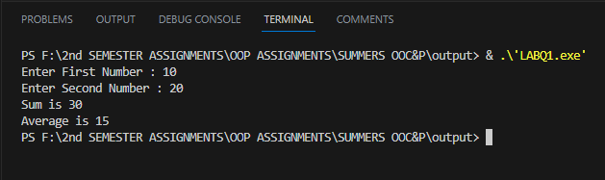

**Q2:-**

#include<iostream>

using namespace std;

void print_matrix(int matrix[3][3]){

    for (int i = 0; i < 3; i++)

    {

        for (int j = 0; j < 3; j++)

        {

            cout<<matrix[i][j]<<" ";

        }

        cout<<endl;

    }

}

void add_matrix(int matrix1[3][3],int matrix2[3][3],int result[3][3]){

    cout<<"The sum of two matrix is "<<endl;

    for (int i = 0; i < 3; i++)

    {

        for (int j = 0; j < 3; j++)

        {

            result[i][j]=matrix1[i][j]+matrix2[i][j];

        }

    }

}

void mult_matrix(int matrix1[3][3],int matrix2[3][3],int result[3][3]){

    cout<<"The product of two matrix is "<<endl;

    for (int i = 0; i < 3; i++)

    {

        for (int j = 0; j < 3; j++)

        {

            result[i][j]=0;

            for (int k = 0; k < 3; k++)

            {

                result[i][j]+=matrix1[i][k] * matrix2[k][j];

            }

        }

    }

}

int main(){

    int matrix1[3][3],matrix2[3][3],sum[3][3],product[3][3];

    //Input first matrix

    cout<<"Enter the element of first matrix: "<<endl;

    for (int i = 0; i < 3; i++)

    {

        for (int j = 0; j < 3; j++)

        {

            cin>>matrix1[i][j];

        }

    }

    //Input Second matrix

    cout<<"Enter the element of second matrix: "<<endl;

    for (int i = 0; i <3; i++)

    {

        for (int j = 0; j <3; j++)

        {

            cin>>matrix2[i][j];

        }

    }

    cout<<"Matrix 1: "<<endl;

    print_matrix(matrix1);

    cout<<"Matrix 2: "<<endl;

    print_matrix(matrix2);

    add_matrix(matrix1,matrix2,sum);

    print_matrix(sum);

    mult_matrix(matrix1,matrix2,product);

    print_matrix(product);

    return 0;

}

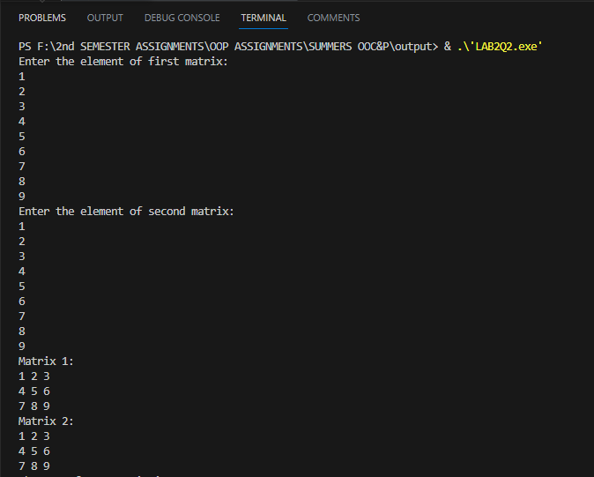

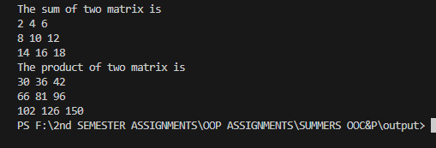

**Q3:-**

#include<iostream>

using namespace std;

int main(){

int time_seconds;

int hrs, min, sec;

cout<<"Enter Time in Seconds: ";

cin>>time_seconds;

hrs = time_seconds /3600;

cout<<"Time in Hours is "<< hrs<<endl;

min = (time_seconds % 3600)/60;

cout<<"Time in Minutes is "<< min <<endl;

sec = time_seconds % 60;

cout<<"Time in Seconds is "<< sec <<endl;

}

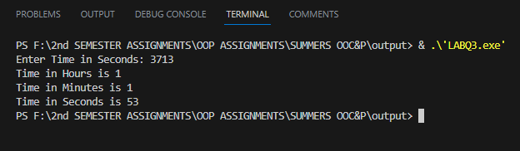

**Q4:-**

#include<iostream>

using namespace std;

int main(){

int amount;

cout<<"Enter Amount In Rupees: ";

cin>>amount;

cout<<"1000's in the Given amount is: "<< amount/1000<<endl;

cout<<"500's in the Given amount is: "<< (amount%1000)/500<<endl;

cout<<"100's in the Given amount is: "<< ((amount%1000)%500)/100<<endl;

cout<<"50's in the Given amount is: "<< (((amount%1000)%500)%100)/50<<endl;

cout<<"10's in the Given amount is: "<<

((((amount%1000)%500)%100)%50)/10<<endl;

cout<<"5's in the Given amount is: "<<

(((((amount%1000)%500)%100)%50)%10)/5<<endl;

cout<<"2's in the Given amount is: "<<

((((((amount%1000)%500)%100)%50)%10)%5)/2<<endl;

cout<<"1's in the Given amount is: "<<

(((((((amount%1000)%500)%100)%50)%10)%5)%2)/1<<endl;

}

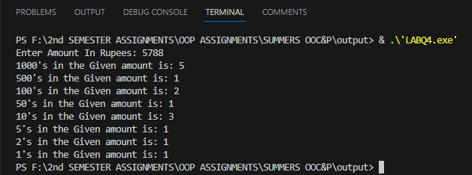

**Q5(i):-**

#include<iostream>

using namespace std ;

int main () {

float temp;

cout<<"Enter Temperature in Fahrenheit ";

cin>>temp;

temp = 5*(temp-32)/9;

cout<<"Temperature in celsius is : "<< temp ;

return 0;

}

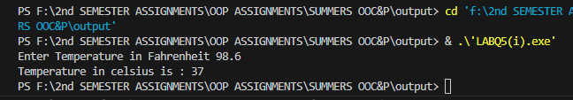

**Q5(ii):-**

#include<iostream>

using namespace std ;

int main () {

float temp;

cout<<"Enter Temperature in Celsius : ";

cin>>temp;

temp = (9*temp)/5+32;

cout<<"Temperature in Fahrenheit is : "<< temp ;

return 0;

}

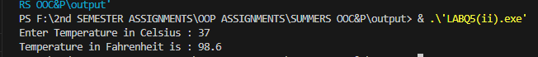

**Q6:-**

#include<iostream>

using namespace std;

int main () {

int num;

cout<<"Enter Two digit Number: ";

cin>>num;

int unitNum = num % 10;

int tenthNum = num /10;

cout<<"Reversed Number is "<< unitNum*10 + tenthNum<<endl;

return 0;

}

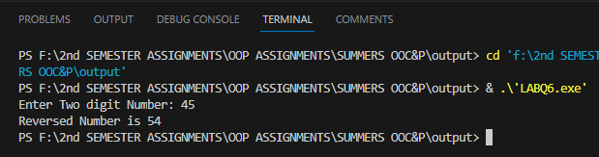

**Q7:-**

#include<iostream>

using namespace std;

int main () {

char chTen;

char chUnit;

cout<<"Enter a two digit Number: ";

cin>>chTen>>chUnit;

int valueTen = chTen - '0';

int valueUnit = chUnit - '0';

cout<<"Numeric value is "<<valueTen*10 + valueUnit<<endl;

return 0;

}

